3-Tier Architecture In AWS

Motive of the task.

involves setting up a three-tier architecture in AWS, including a presentation tier (front-end), application tier (back-end logic), and database tier. You'll create a Virtual Private Cloud (VPC), subnets, internet gateway (IG), NAT gateway, route table, EC2 instances, launch templates, and auto scaling groups to distribute the workload across different tiers.

Architectural Diagram

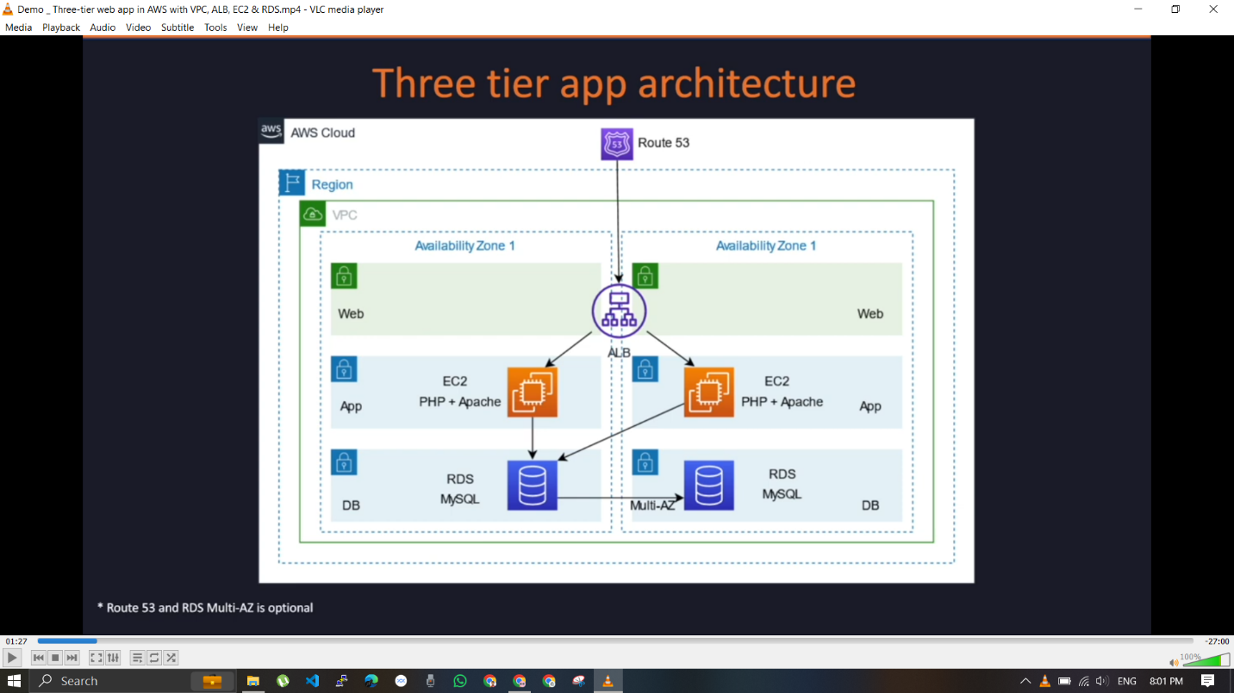

Steps :

Login to your Console Navigate to VPC services

Create a VPC and give CIDR value = 10.0.0.0/16

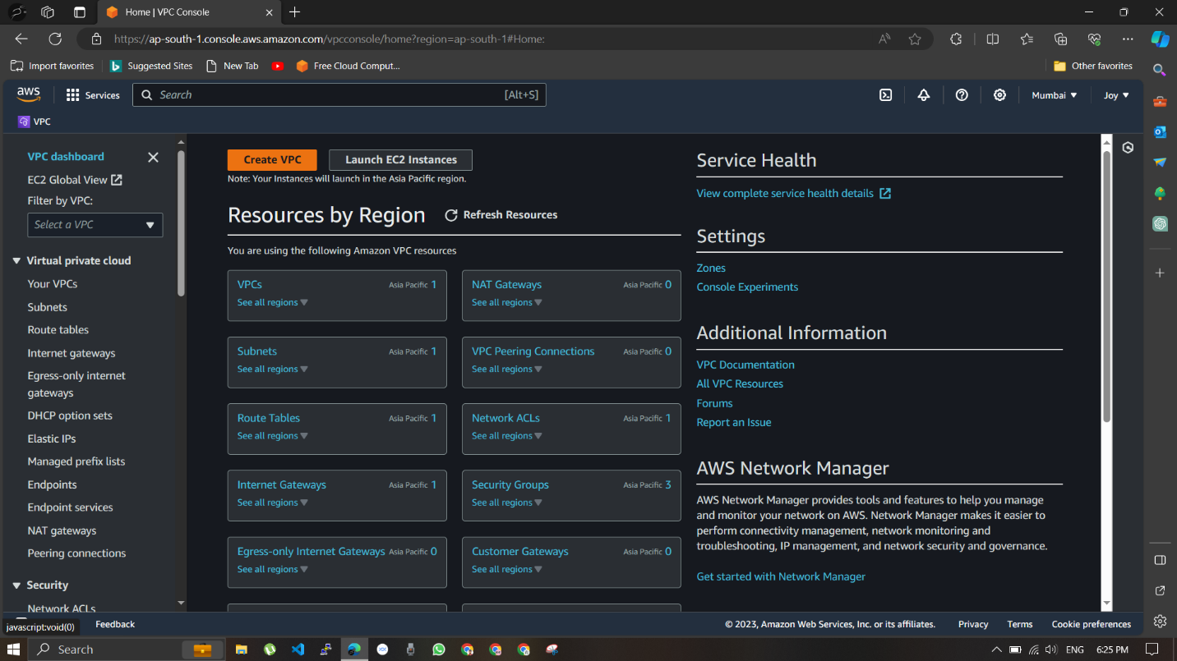

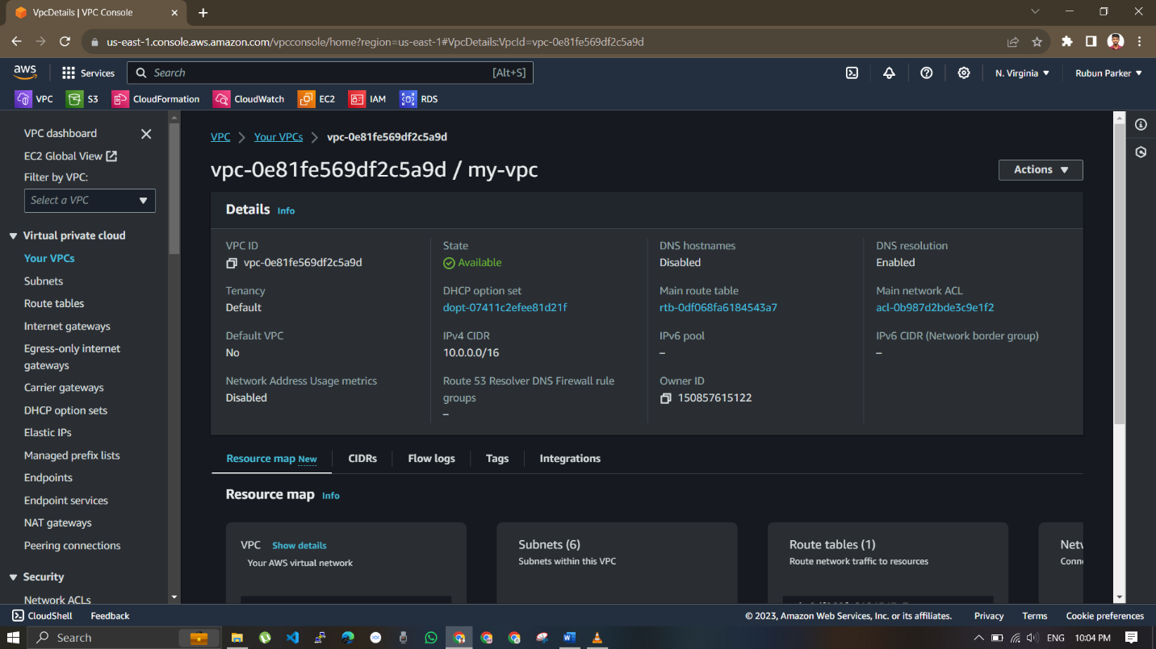

Go to subnet section and create subnets for web-tier , Application-tier , and Db tier

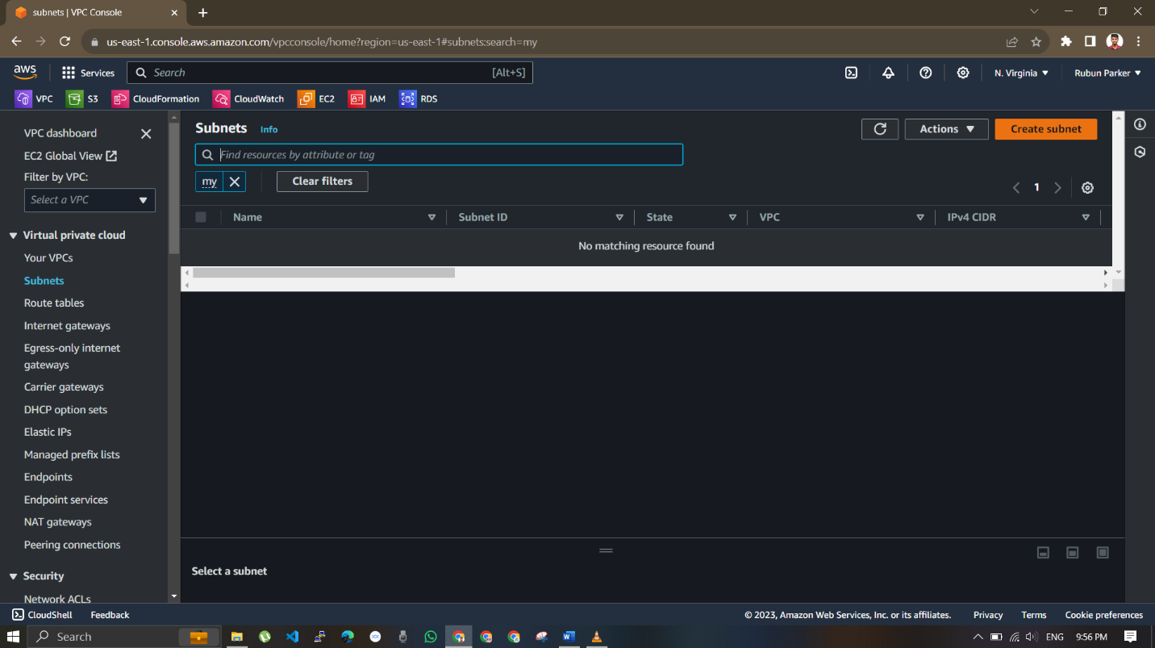

Put a set of subnets of web tier , App tier and DB tier in one avaliblity zone us-east 1a

Put a another set of subnets of web tier , App tier and DB tier in one avaliblity zone us-east 1b

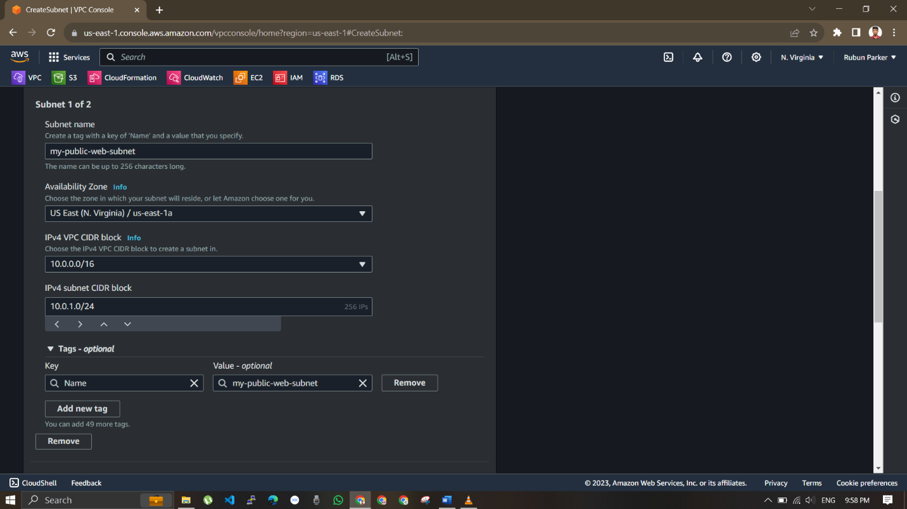

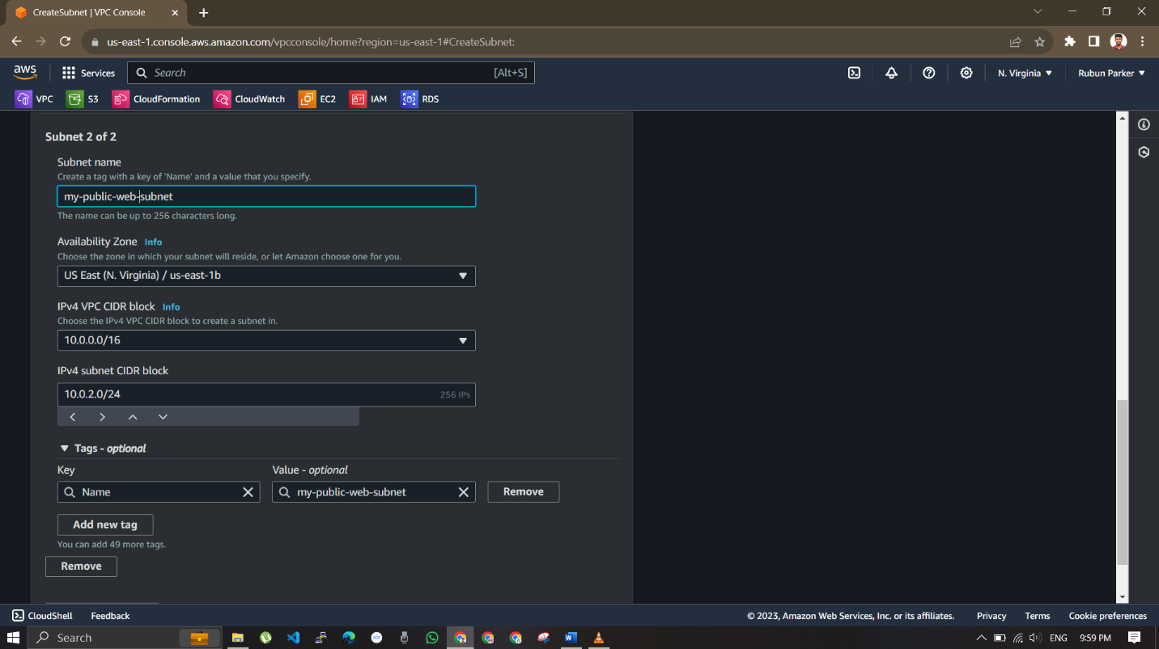

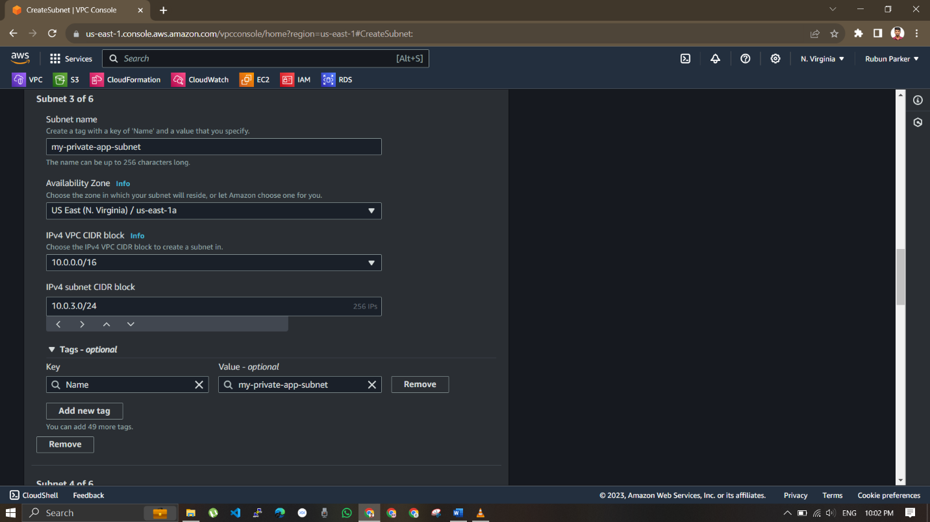

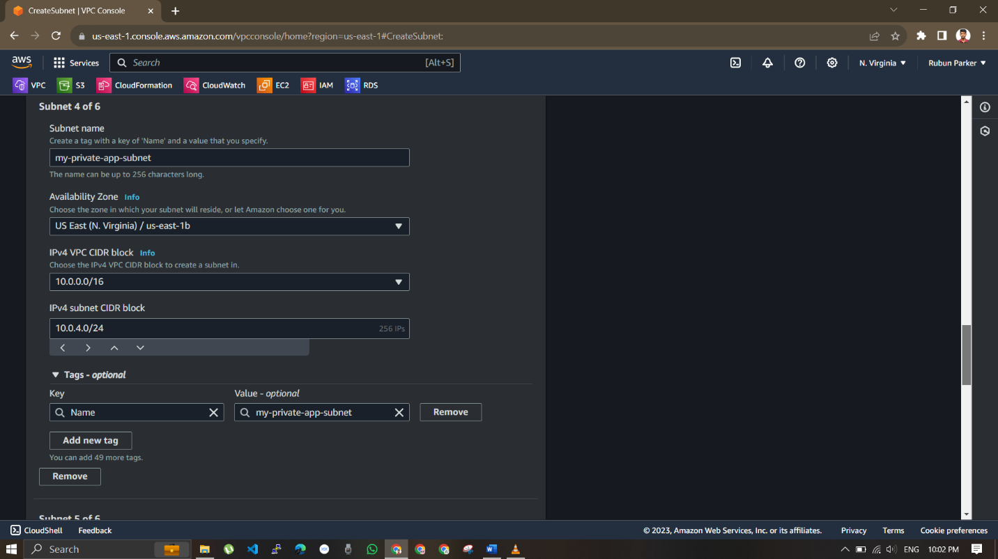

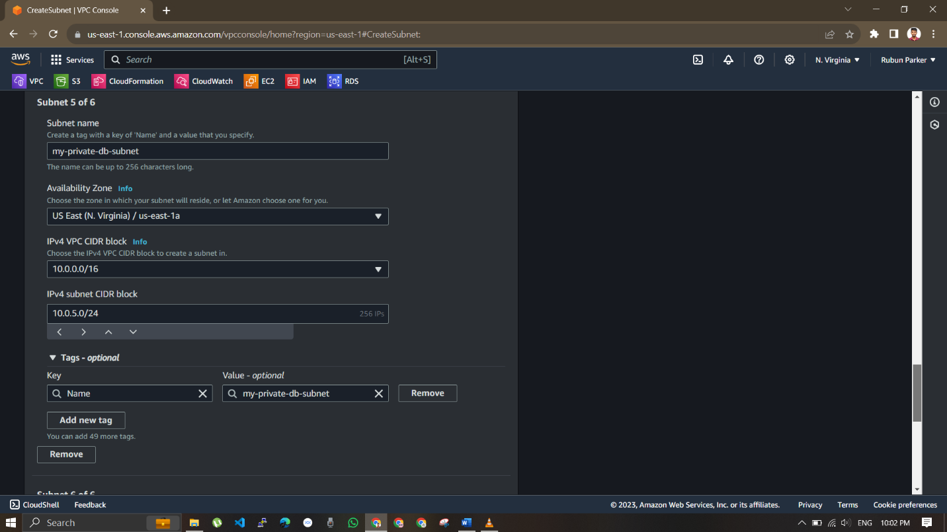

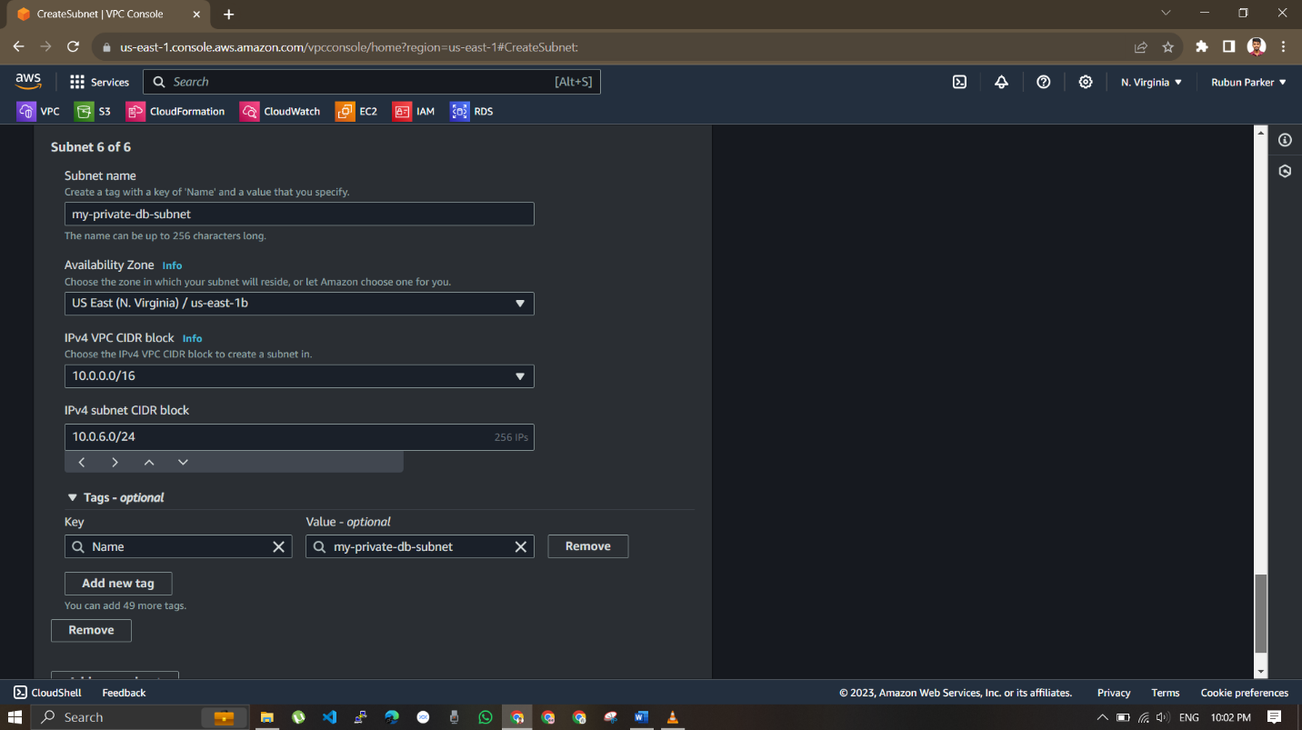

Thus subnets are created in two different availblity zone

Then create a route table for each tier , thus 3 – route table for each web , app ,DB tier , a route table will connect within two different availbility zone

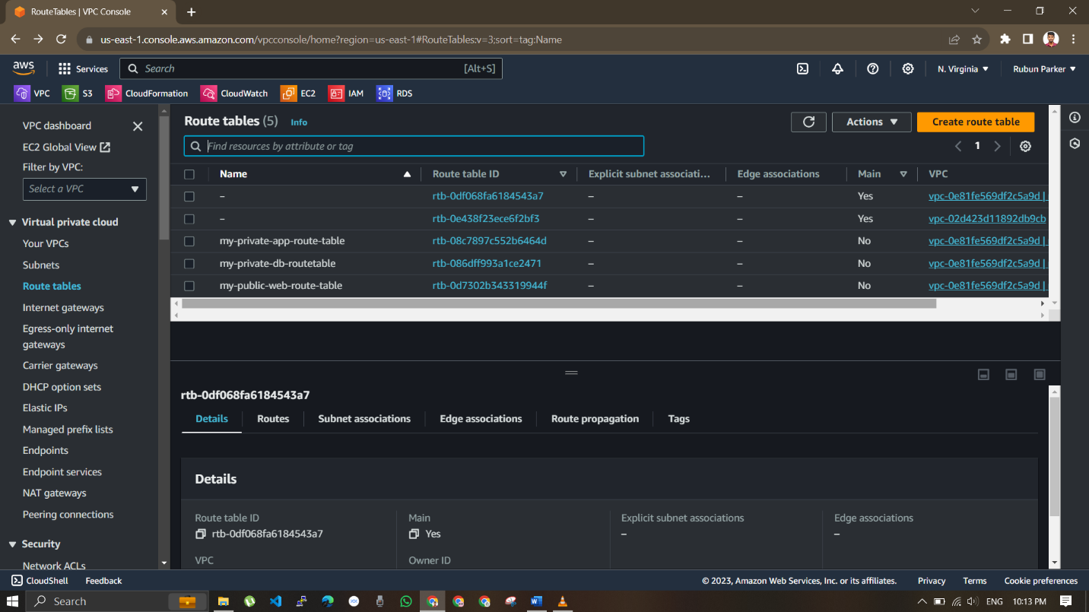

Associate the route table with subnets

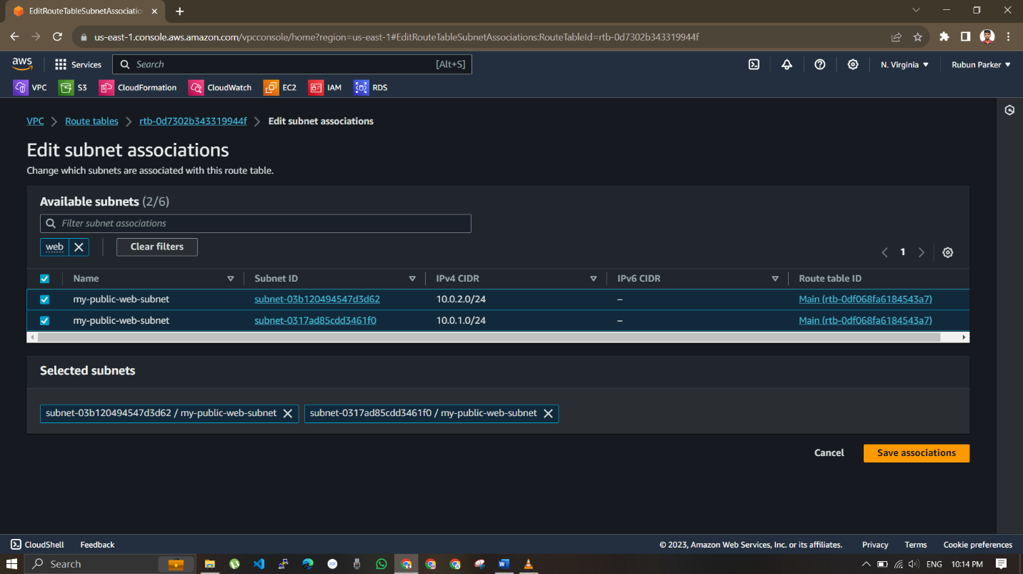

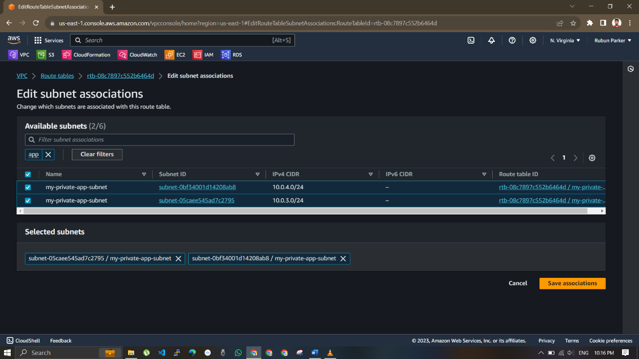

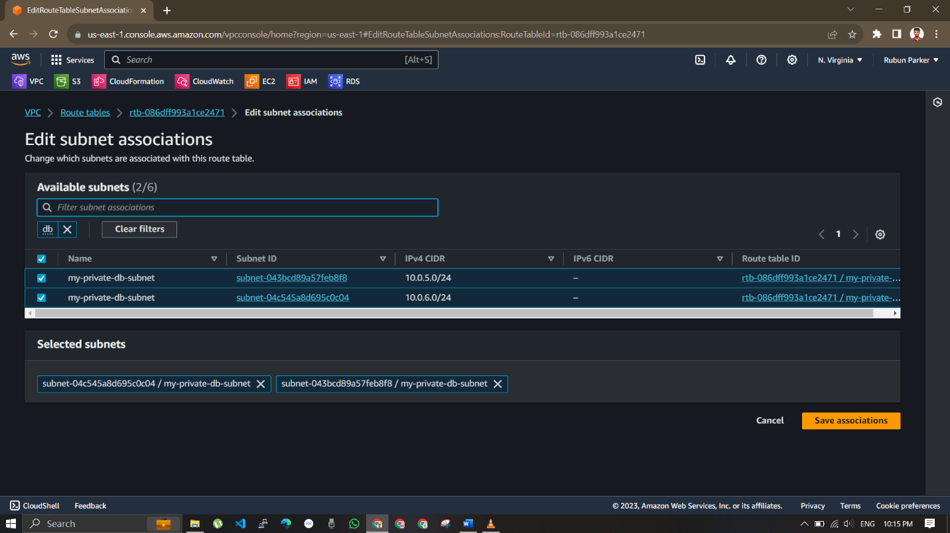

Create a internet gate way to attach internet to the created VPC ,

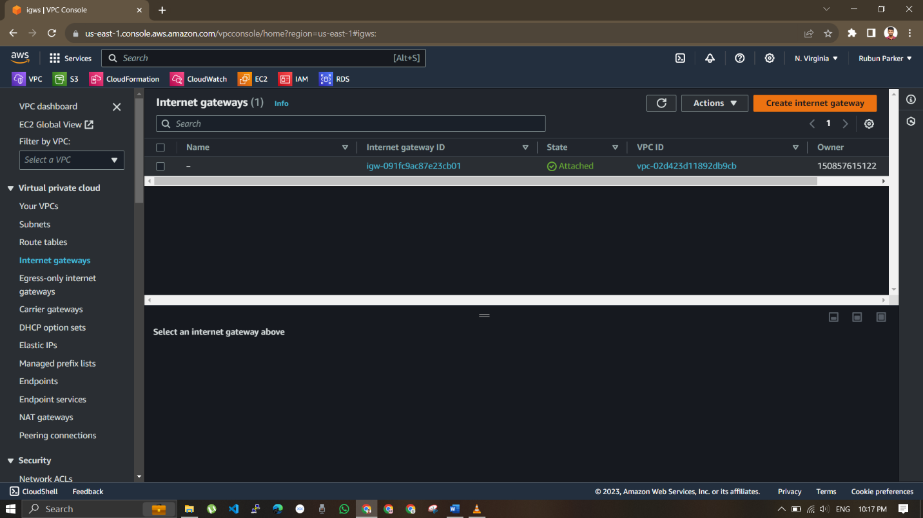

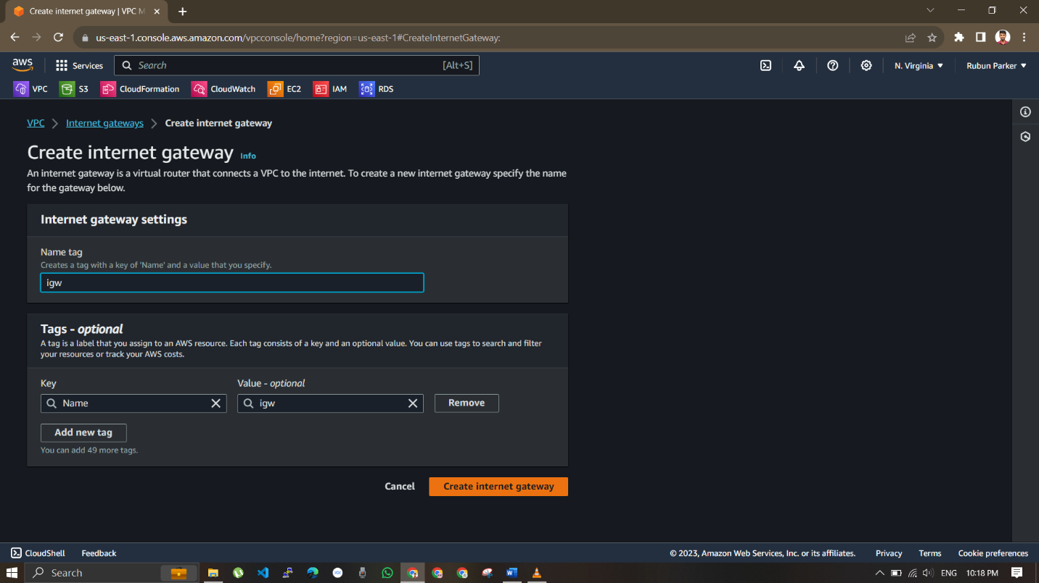

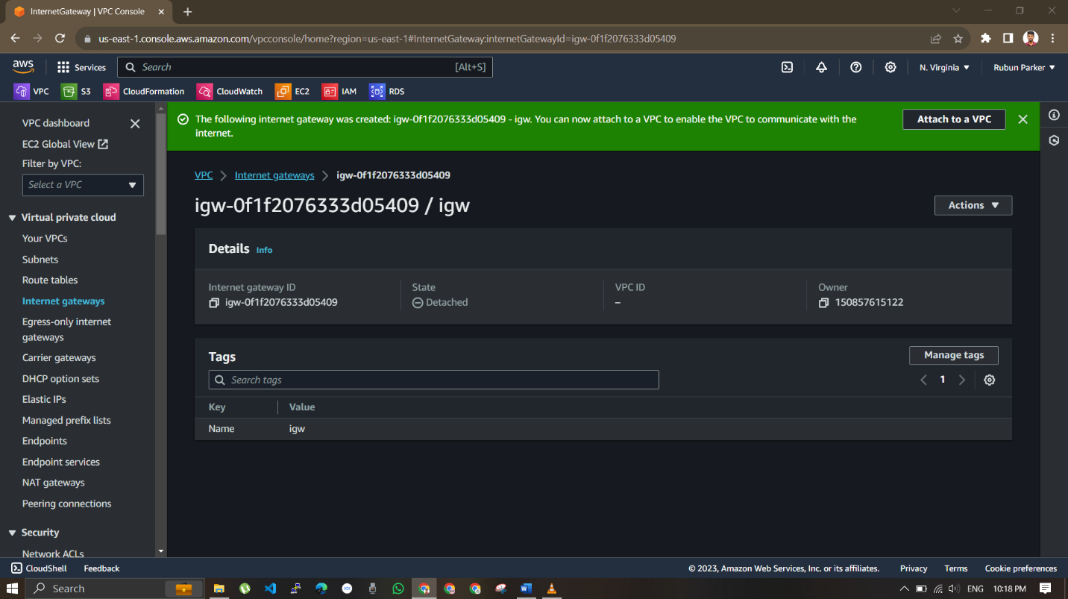

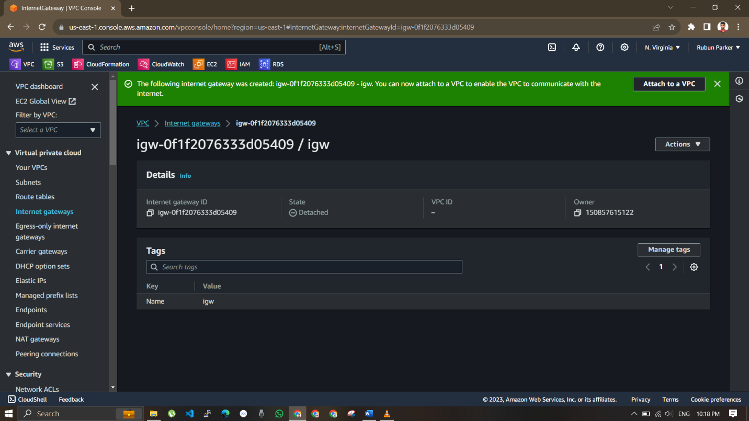

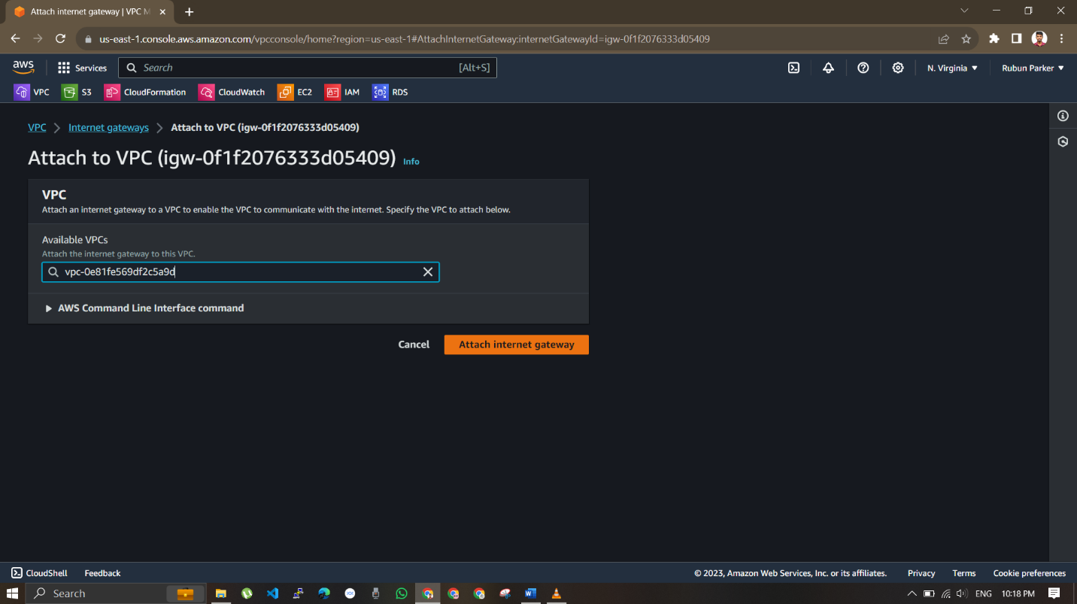

Create a NAT gateway by allocating elastic IP , select the public subnet

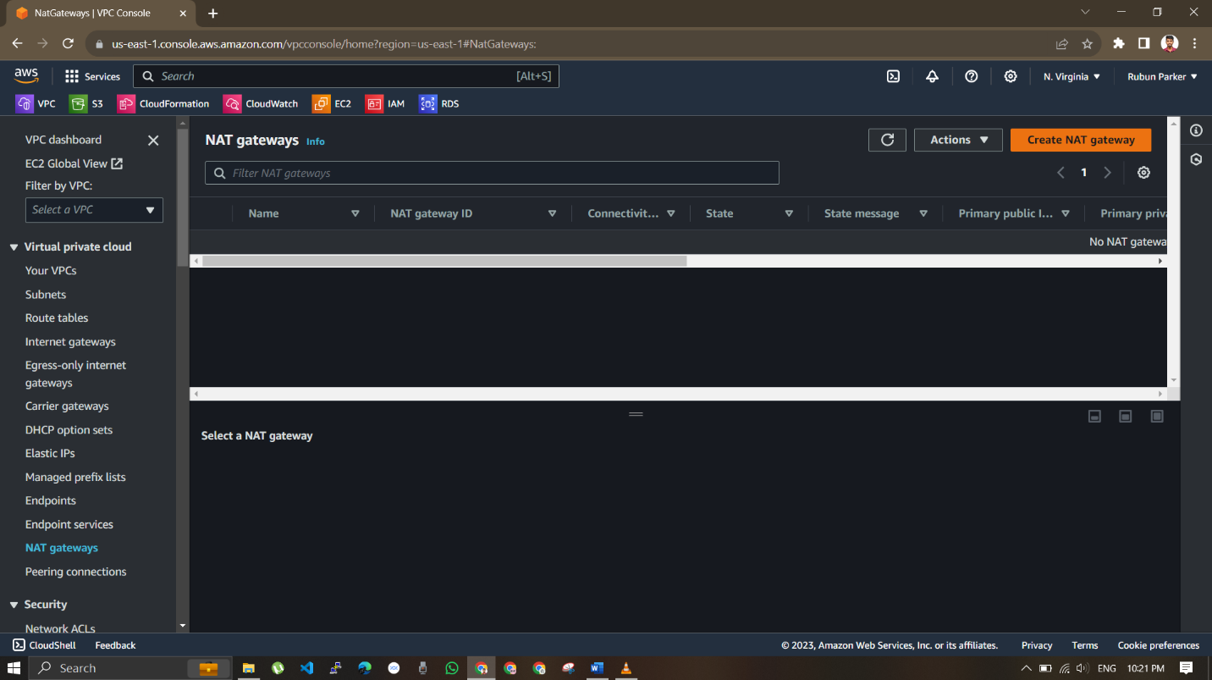

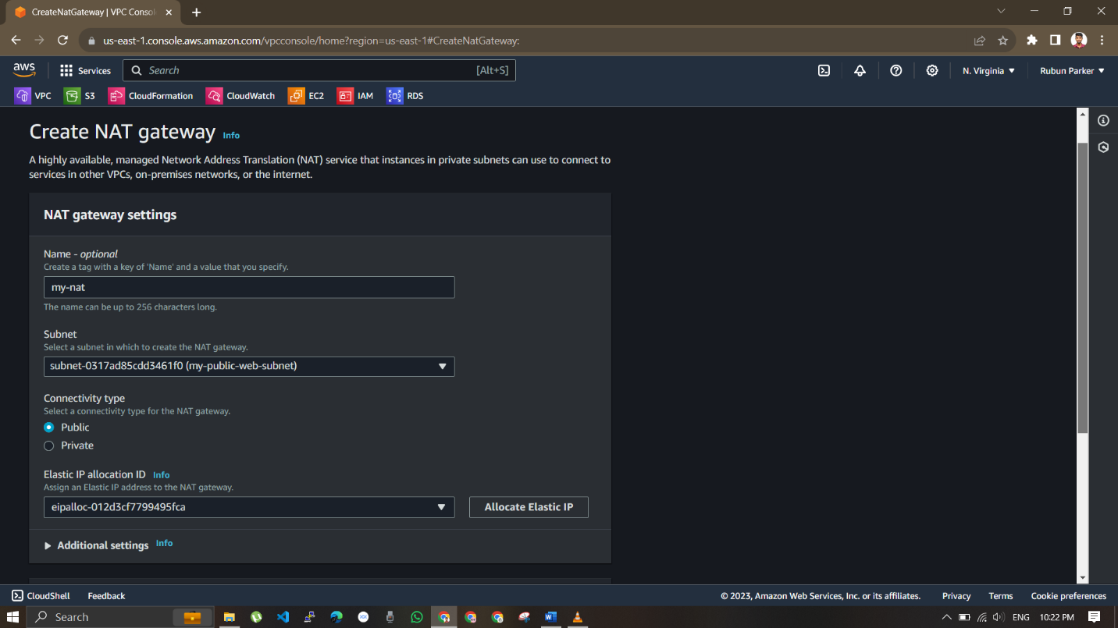

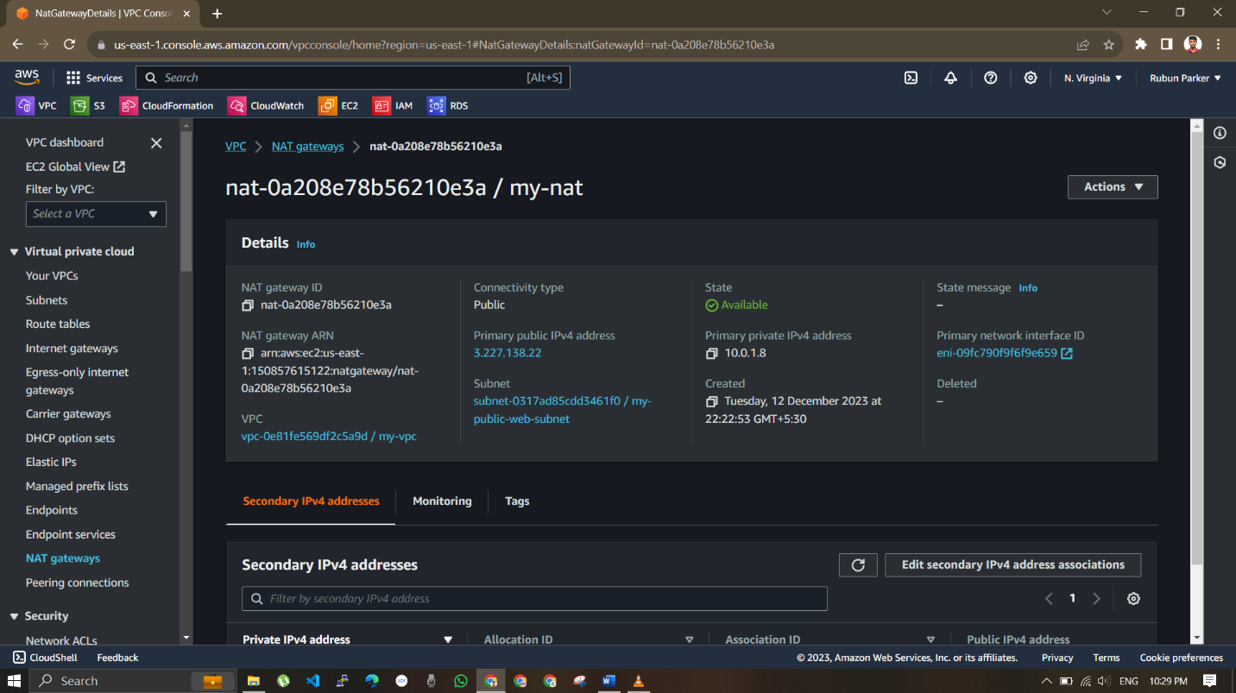

Add route for each rote table and point it to IG and NAT

Select the route table click routes and edit route

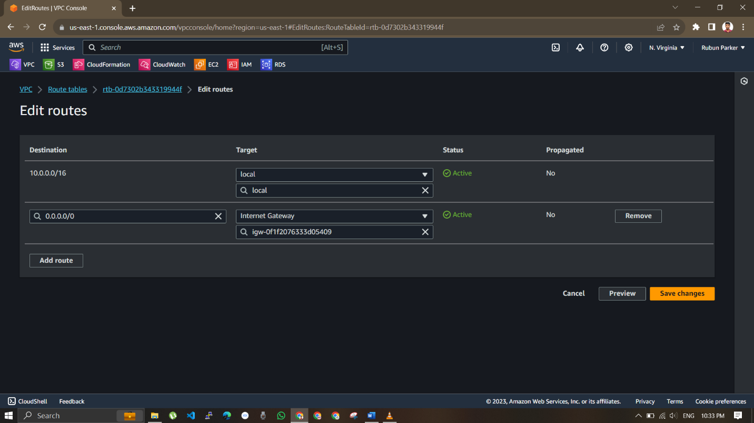

Click add route and select internet gate way and select the created internet gateway

Select the route table click routes and edit route

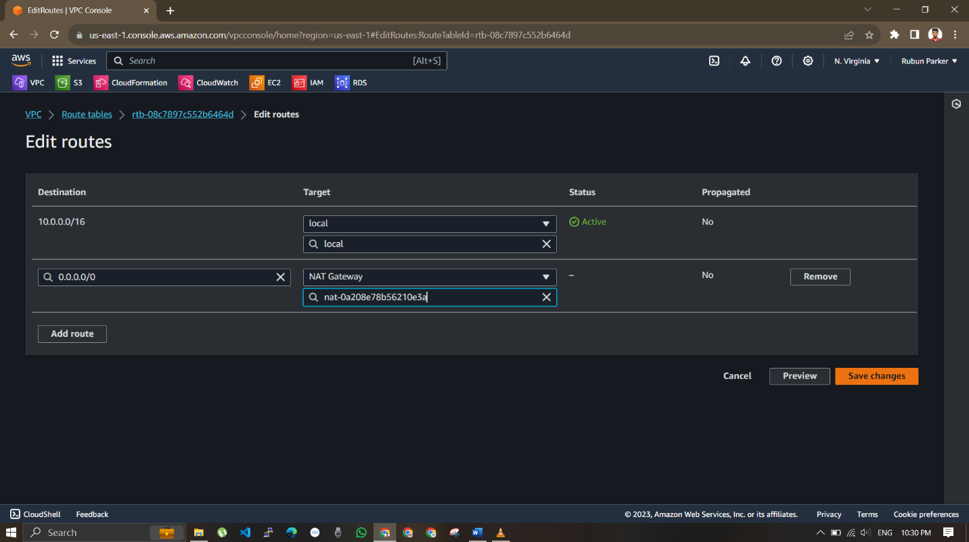

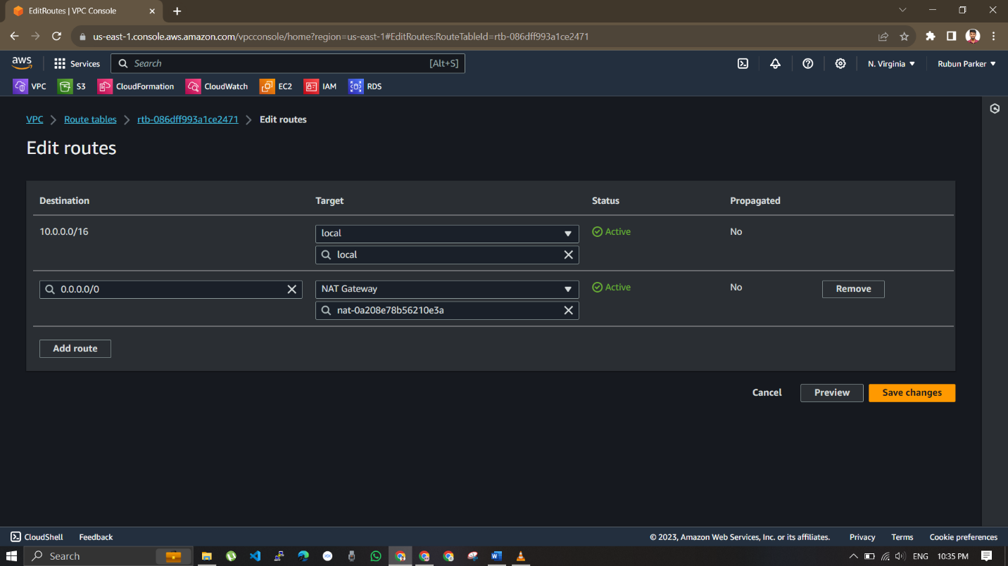

Click add rule and select 0.0.0./0 and select nat gateway

Web tier to pointed to Internet gateway , and rest are pointed to NAT

Navigate to EC2 console

Create a instance in the web subnet that would be our Jump server and create a new security group

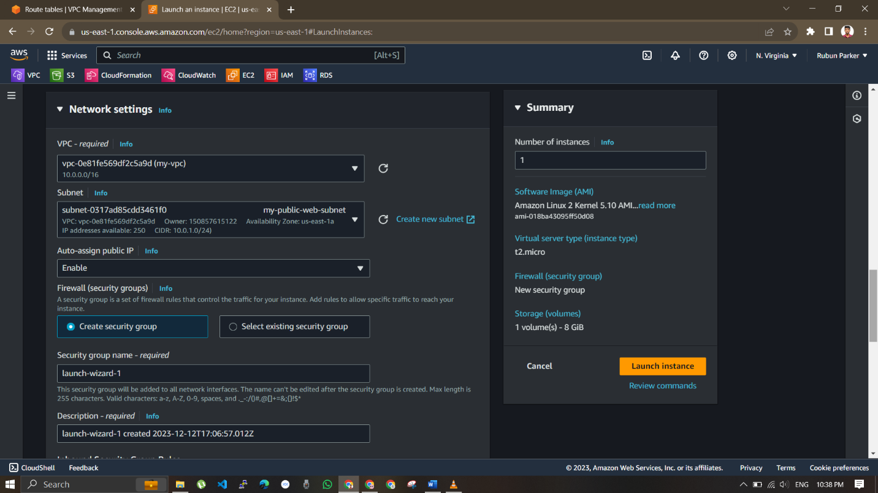

And create a instances in the app subnets and create a new security group and configure the same for both app subnet instances.

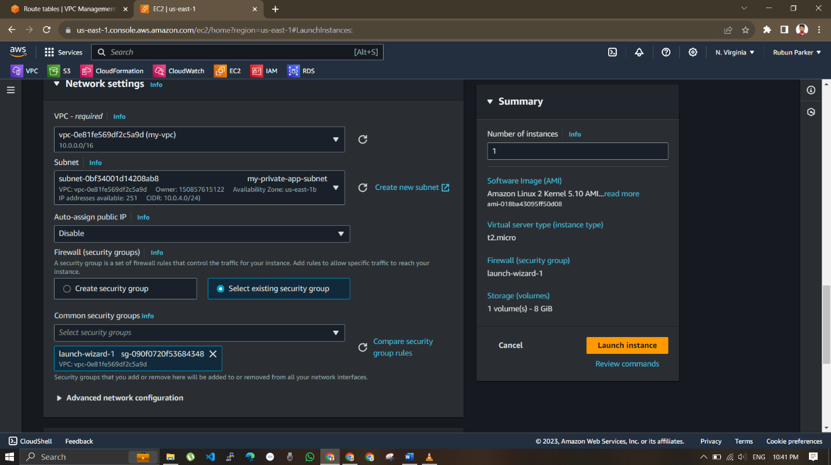

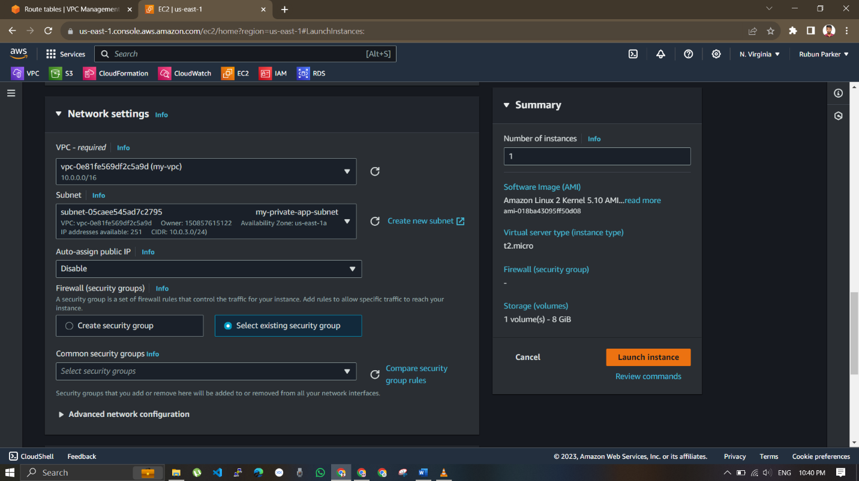

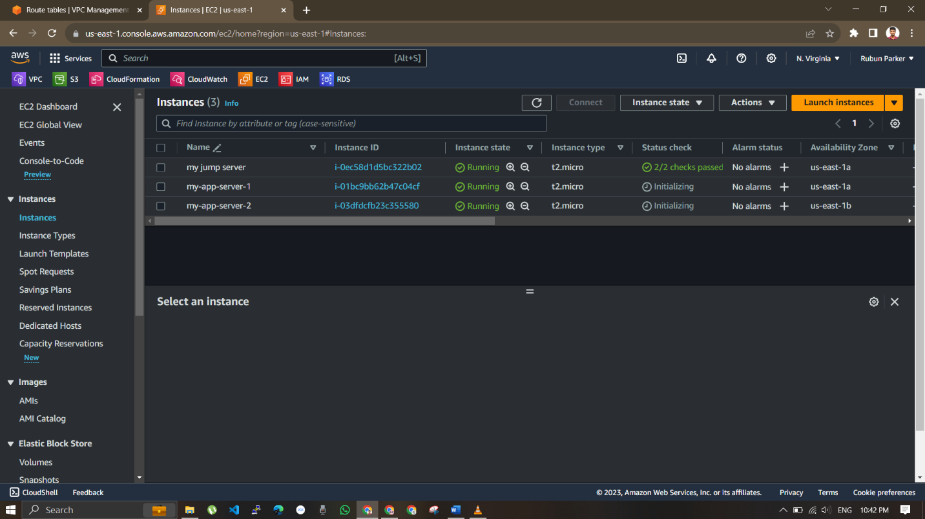

Create a application load balancer with following requsites

Application load balancer

Internet facing

Security group – 80

App subnet instances

Target group with app subnet instances

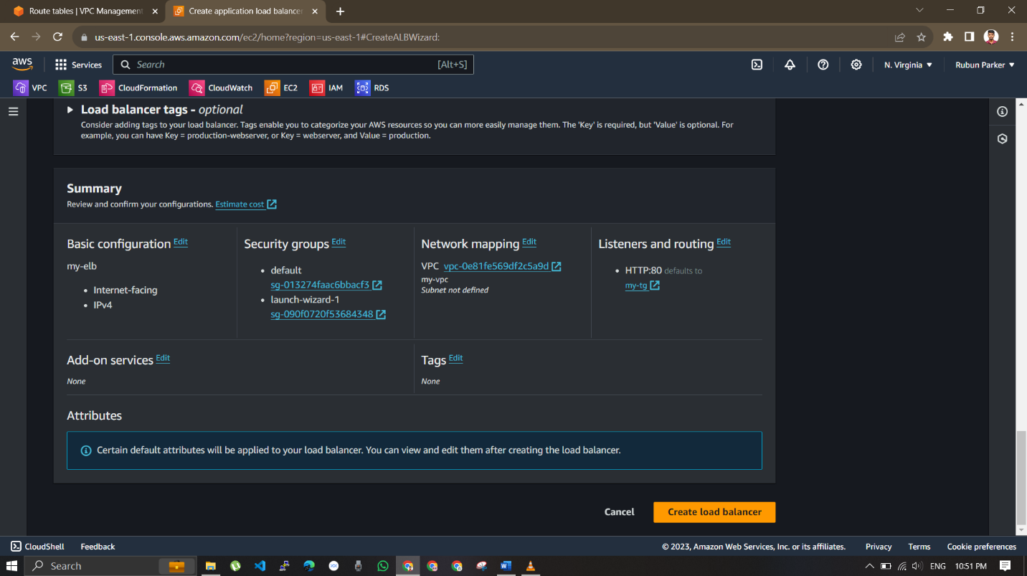

Click target group and selct the two app instances

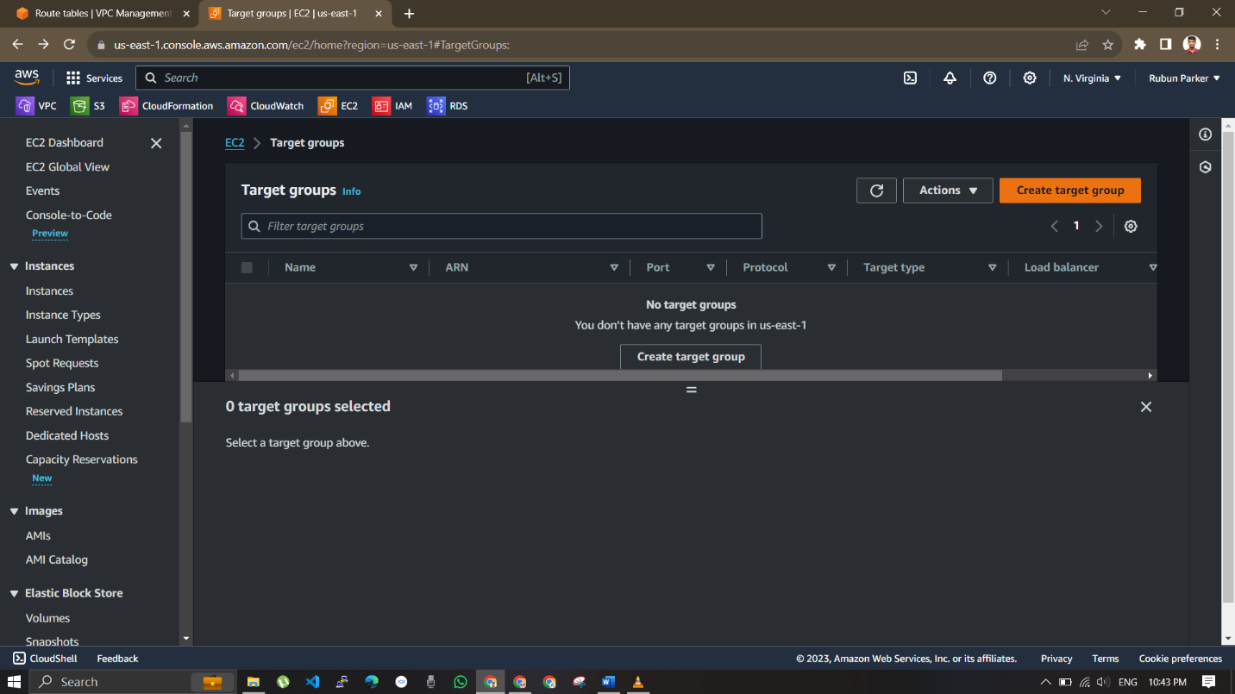

Select instances

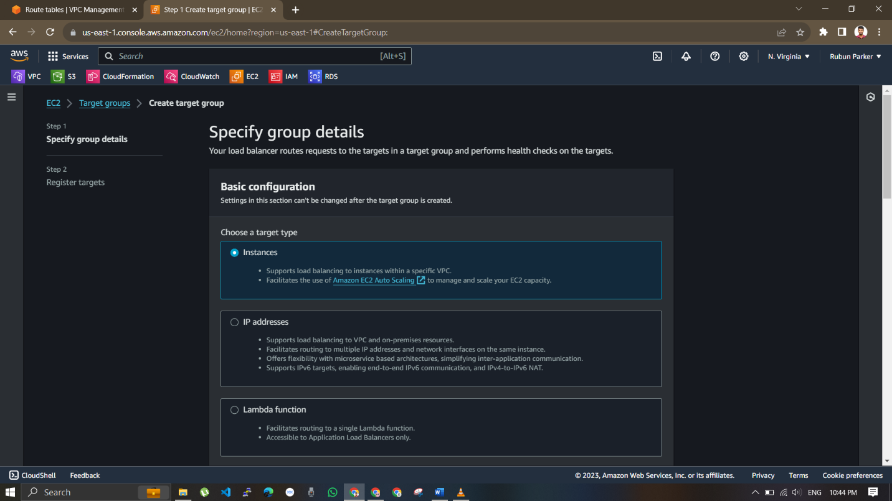

And select my-vpc

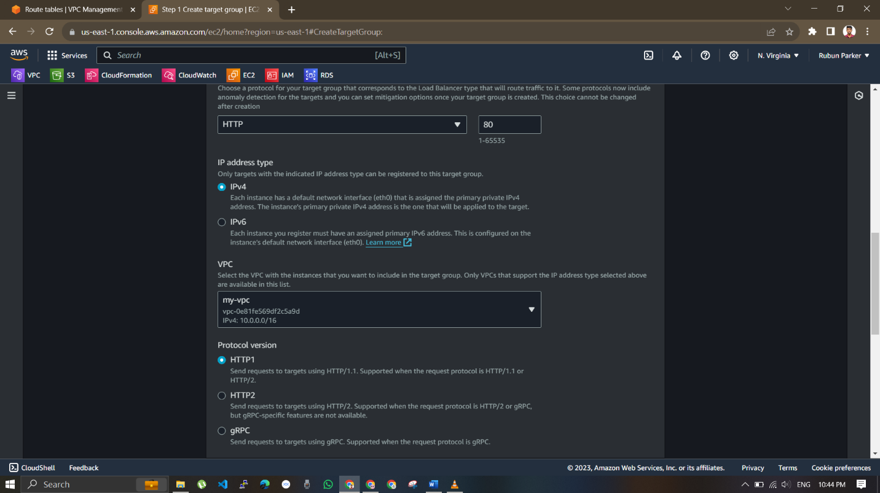

And select the target which is our two app instances

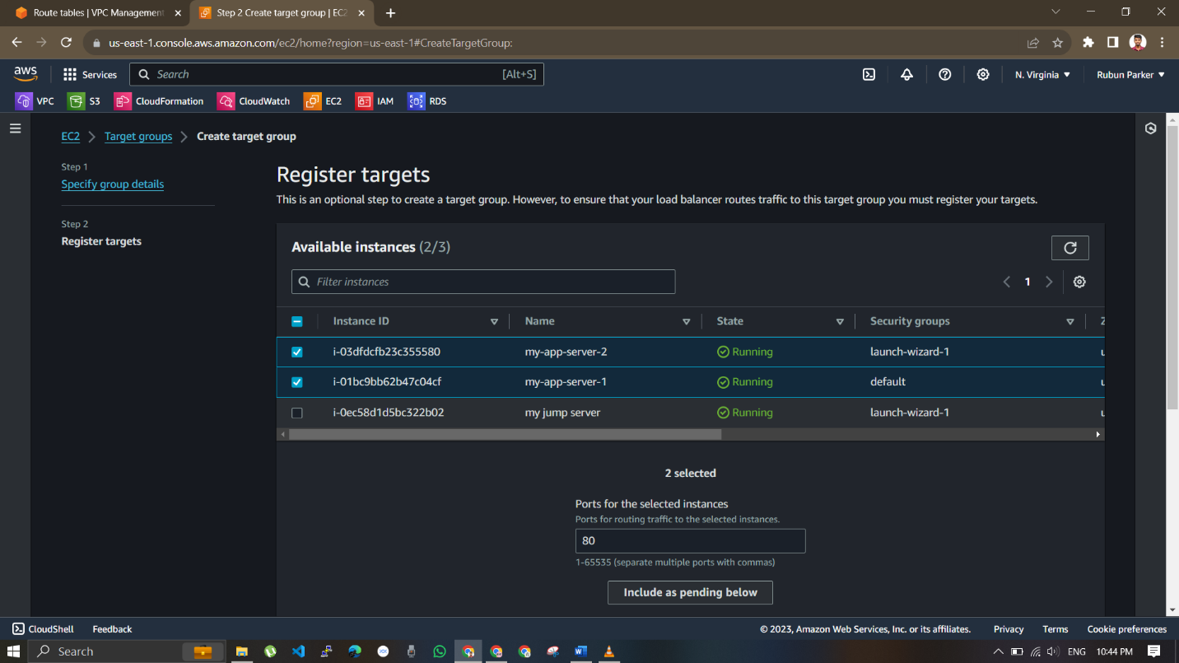

And click create target group

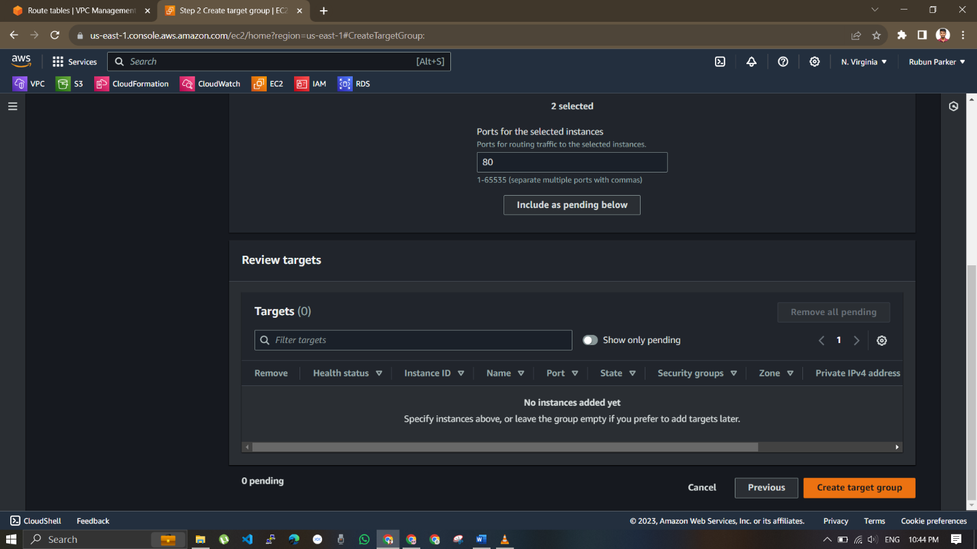

Navigate to RDB console

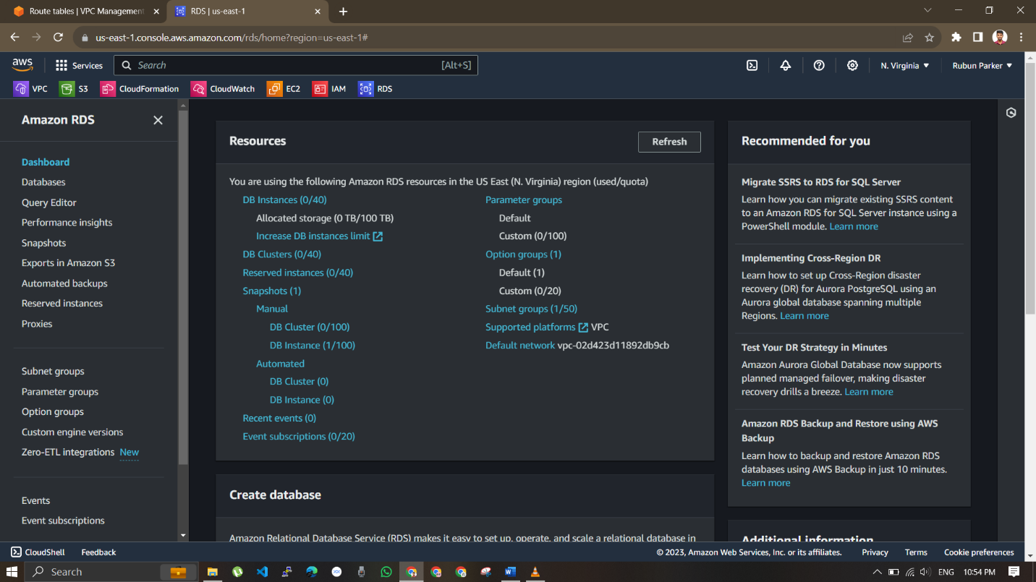

Create a new subnet groups

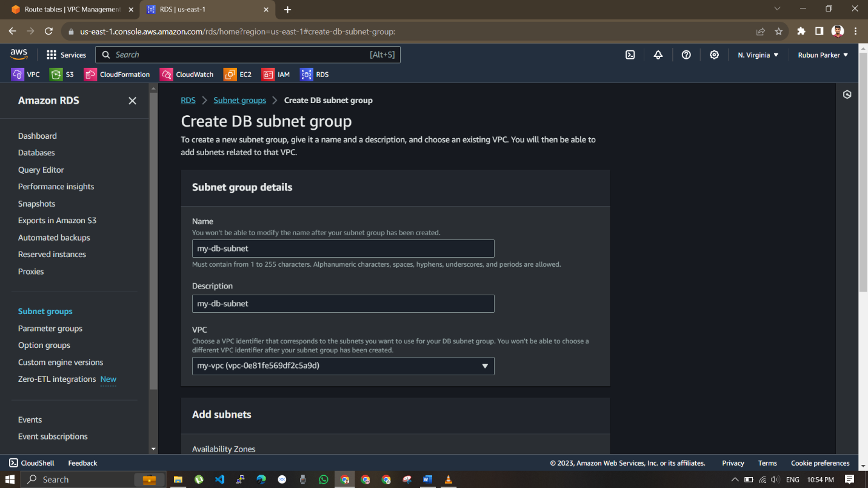

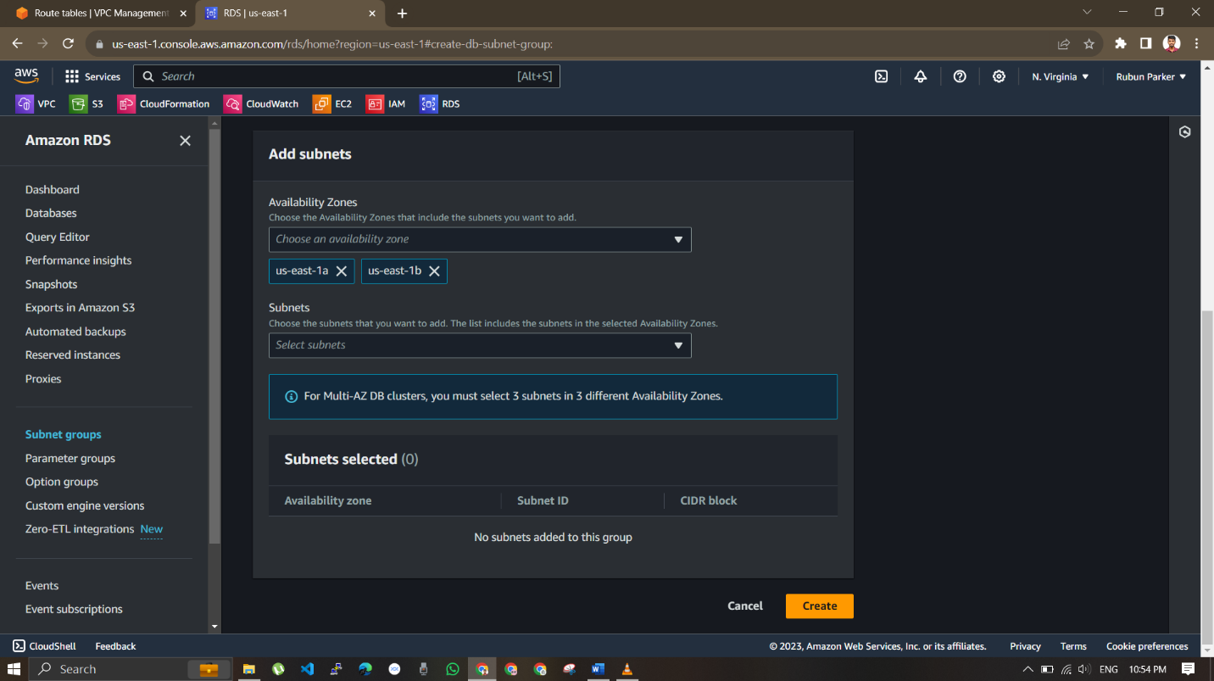

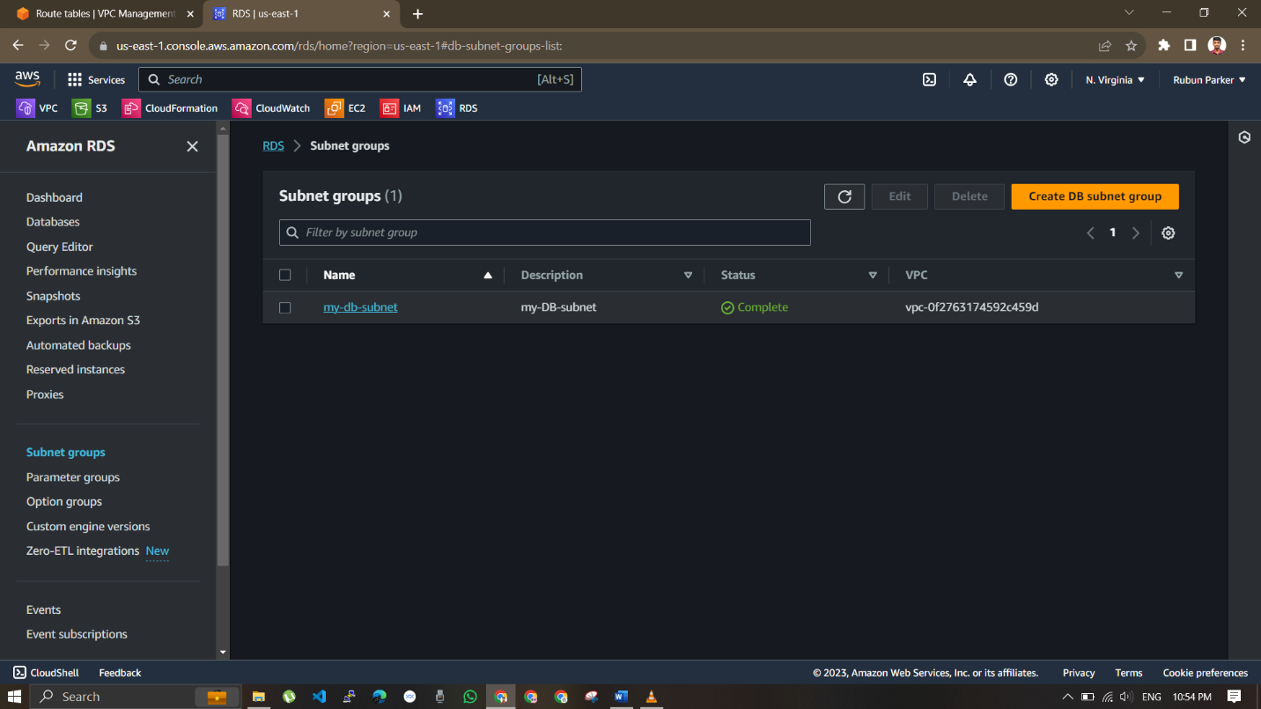

Select the created VPC , availablity zone , and DB subnets,

Create a database and ,

Give a name to the database and select mysql,

Give master passwords,

Select created VPC and DB subnets and click create Database.

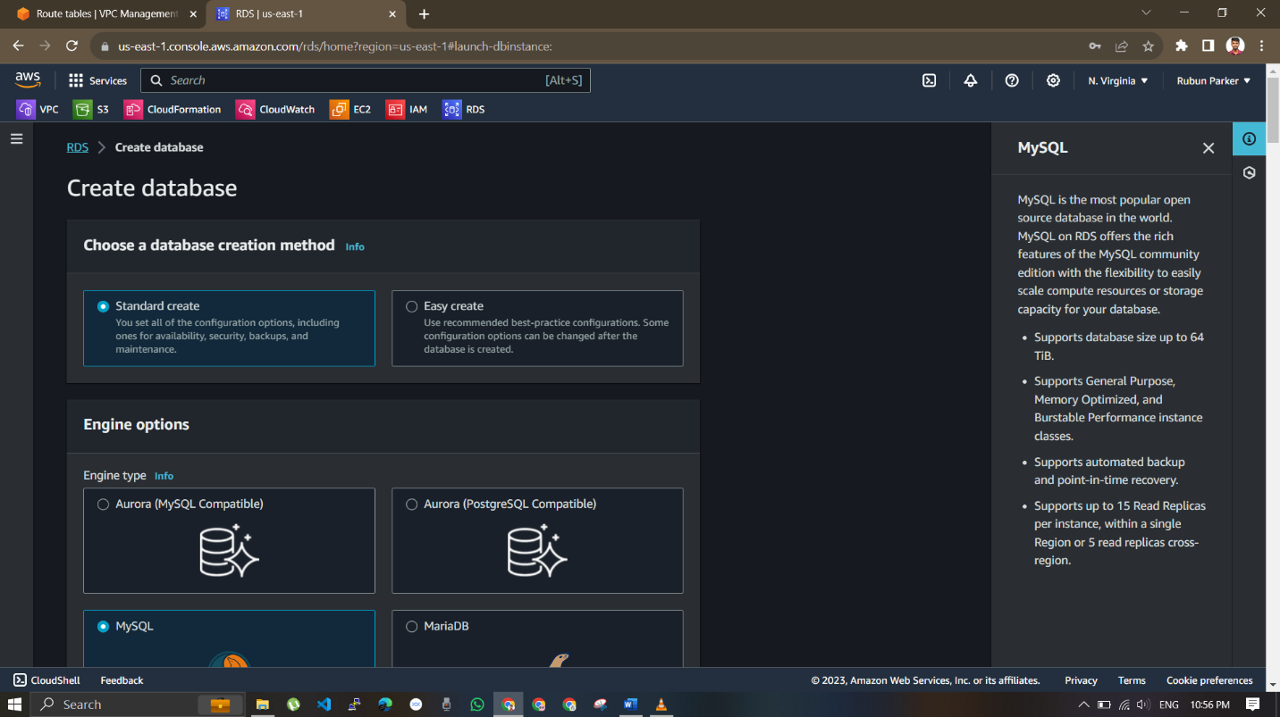

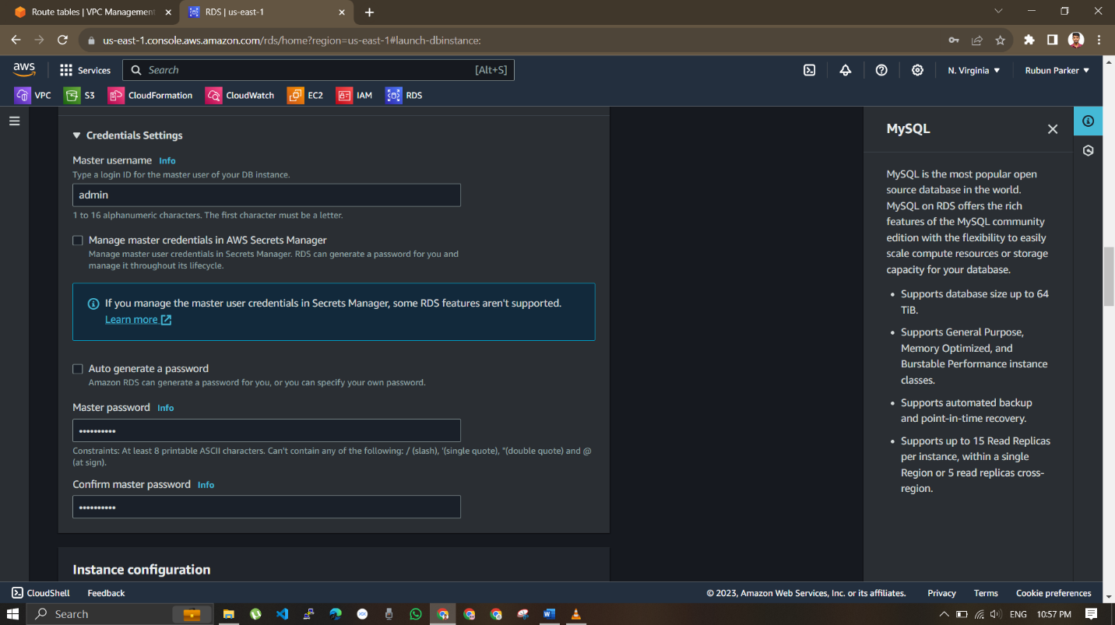

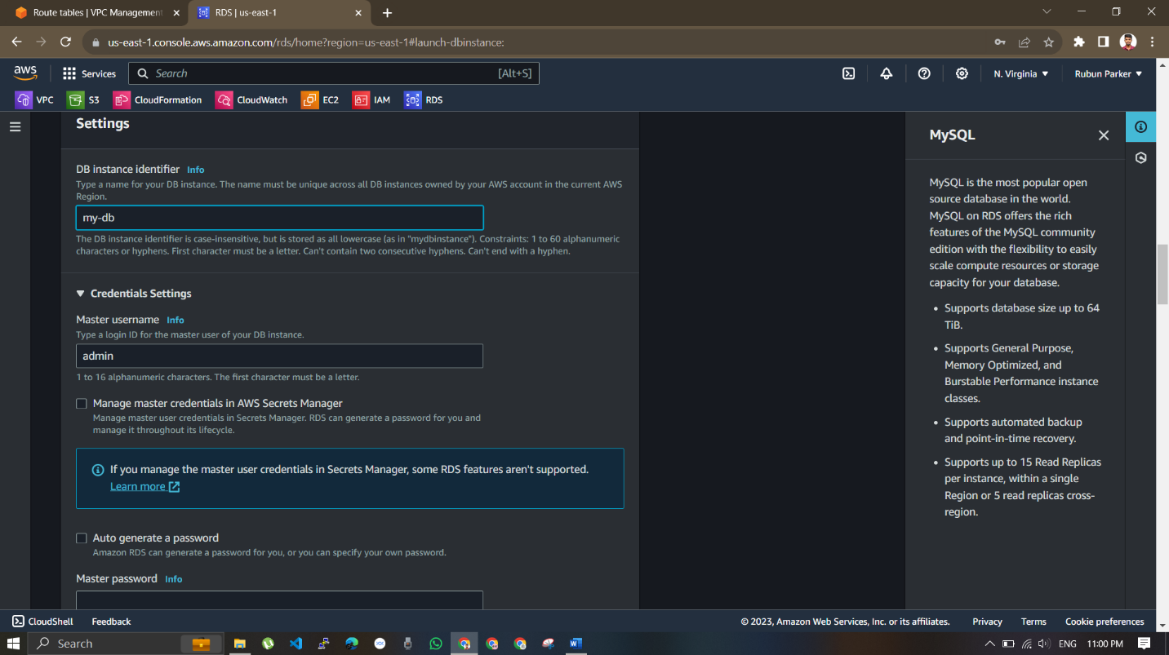

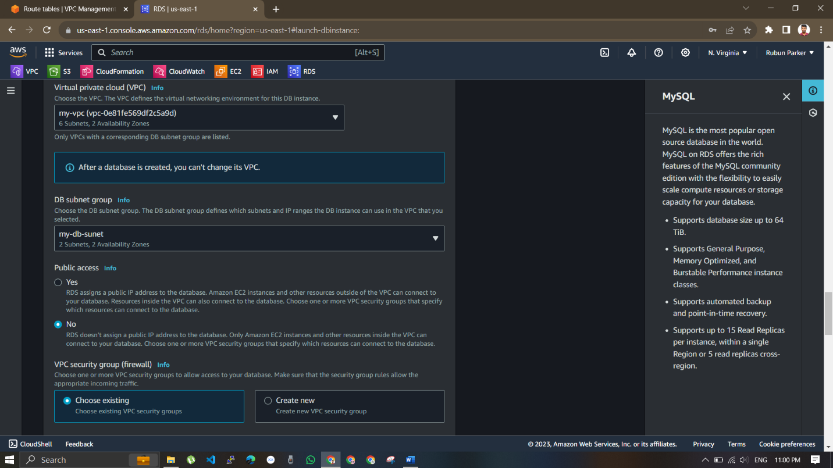

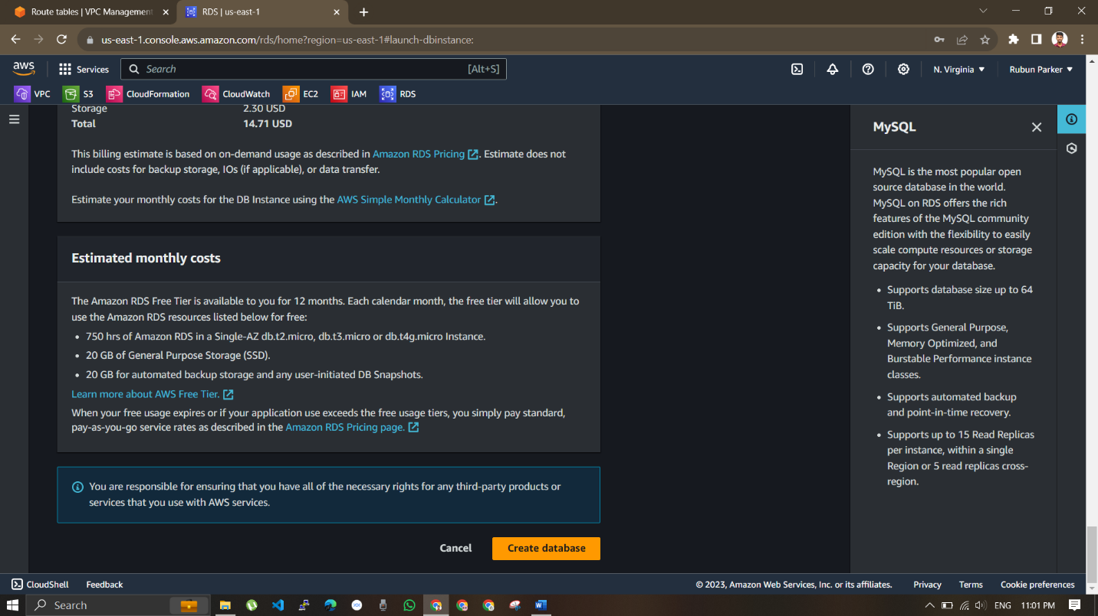

A 3-tier architecture is created